Dated: July 23, 2024
Allentown FSDO
Justification to RECLASSIFY Pilot Deviation on 5/20/2024, N530TB, PHL-M-2024/05/20-0005:
The pilot of N530TB was using ATC procedures that have been utilized for operations into and out of Essington Sea-Plane Base (9N2) for over 40 years.
These procedures were developed with the intention of allowing aircraft operating to/from the Essington Sea-plane Base to operate without the need to contact PHL ATCT. They were developed due to accommodate seaplane that were once based there that did not have the electrical systems to support transponder and communications equipment.
These procedures were developed prior to the institution of Class-B Airspace. The PHL Class-B Airspace shelves were specifically designed to accommodate operations at 9N2 utilizing the existing procedures and at Boeing Helicopter Center 3 South Heliport (PS13) and Piac Heliport (10PA) using similar procedures.
These procedures have been utilized without incident since before the institution of the PHL Class-B Airspace.
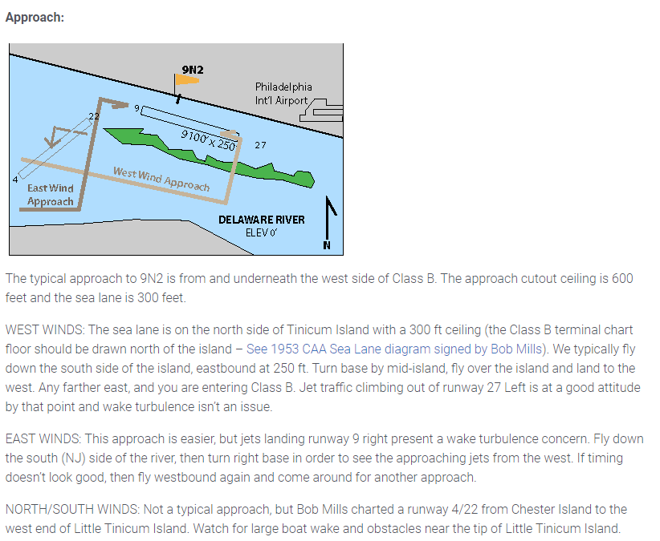
PHL ATCT has worked under the premise that these 3 airports were outside the PHL Class-B Airspace and when developed our Radar Video Maps indicated the Class-B shelf which encompasses the seaplane lane extended to the North shore of the river.
In reviewing this Pilot Deviation, PHL ATCT has determined that the procedures utilized to allow operations into and out of these 3 airports do work as intended. The premise that the Class-B Cutout extended to the North shore of the river is incorrect and that following the long age developed procedures does not keep aircraft operating to these 3 facilities clear of the Class B. It was also discovered that our Radar Video maps do not match the current Legal Description of the Class B Cutout.
Considering these findings, we do not consider that the actions of the pilot of N530TB constitute a Pilot Deviation and, PHL-M-2024/05/20-0005 should be re-classified as a “No-Incident”.

Philadelphia ATCT will undertake actions to correct our Radar Video Maps and develop new procedures for the 3 Facilities.

